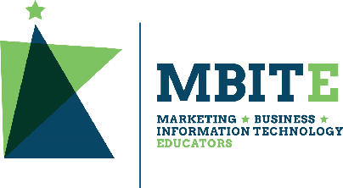

Minnesota Management, Marketing, Finance and Technology Competencies:

Career Exploration Cluster [Updated Summer 2026]

These academic frameworks were partially funded by the Minnesota Department of Education using federal funding, Carl D. Perkins Career and Technical Education Act of 2006, as amended by the Strengthening Career and Technical Education for the 21st Century Act (Perkins V). The contents of this tool do not necessarily represent the U.S. Department of Education, the Minnesota Department of Education, and Minnesota State and you should not assume endorsement by the federal or state government.

Career Exploration Cluster
The Career Exploration Cluster includes courses in which students explore and prepare for career opportunities in business-related fields, and identify alignment of their current skills and aptitudes to these opportunities. A wide range of experiential learning, mentor connections, and postsecondary visits are typically utilized to help students develop personal and professional career development plans for post-graduation career and college readiness. Students develop skills including verbal and written communications (resumes, applications, information and job interviews), organization and time management, and technology applications. Students who enroll in Career Exploration Cluster courses develop a plan for further pursuit of careers in financial services, hospitality and tourism, management and entrepreneurship, marketing and sales, and digital technology.

Cluster Courses
Introductory Courses | Intermediate Courses | Advanced Courses
12994 Introduction to Business Careers (140710) OR 12151 Introduction to Marketing Careers (040800) | blank | 12991 Emerging Career Pathway Studies

Experiential Learning and Work-Based Learning
Experiential Learning opportunities should be embedded throughout a CTE Business and Marketing program, and could include industry tours, job shadowing experiences, service learning experiences, and student-led business operations. Work-based Learning (WBL) experiences as a continuation and application of classroom learning can also be developed. Work-based Learning includes both internship and Youth Apprenticeship opportunities for approved WBL programs with licensed WBL coordinators. Experiential Learning is a required component of every management, marketing, finance and technology program, with the intention that opportunities will be available for every student. Through involvement in Experiential Learning activities, students experience multiple career pathway occupations, learn expected workplace behavior, develop industry-specific technical skills, and are given opportunities to apply academic and occupational skills in the workplace or a simulated workplace environment.

Social-Emotional Learning
Helping students develop social and emotional competence is an essential component in their preparation to be successful adults. Career and Technical Education (CTE) classrooms and workplaces should foster the acquisition and application of the knowledge, skills and attitudes needed for social and emotional development. These include: self-awareness, self-management, social awareness, relationship skills, and responsible decision-making. Explicit teaching of, and regular student rehearsal of, these skills will lead to greater academic, social, and career outcomes.

Career Technical Student Organizations: Business Professionals of America (BPA) and DECA
Student participation in career technical student organizations (CTSOs) is considered as essential component of a quality career and technical education program. Minnesota Business Professionals of America (BPA) and Minnesota DECA provide students with opportunities for growth through education, competition, community service and professional development. Career and leadership development activities are embedded throughout the entire career cluster through classroom instruction and projects, as well as the DECA and BPA competitive event programs.

Assessing Competencies with Formative and Summative Assessments
Employability skill performance indicators and benchmarks are typically assessed with “formative assessments.” The goal of formative assessment is to monitor student progress during an instructional unit to provide ongoing feedback that can be used by instructors to improve their teaching and by students to improve their learning. Formative assessments help students identify their strengths and weaknesses and target areas of needed improvement. They also help teachers recognize where students are struggling so that problems can be addressed in a timely manner. Formative assessments generally have low or no point value.
Career pathway technical skill competencies (identified by course in this document) are typically assessed with “summative assessments.” The goal of summative assessment is to evaluate student learning at the end of an instructional unit by comparing it against the competency or measurement to which the unit was aligned. Summative assessments have point values which generally are factored into a final course grade.

Business Clusters and Programs of Study in New Minnesota Career Wheel
Business program courses typically are categorized under one of six career clusters in the new Minnesota Career Wheel:
- Management and Entrepreneurship
- Marketing and Sales
- Financial Services
- Digital Technology
- Hospitality, Events and Tourism
- Entertainment, Arts and Design

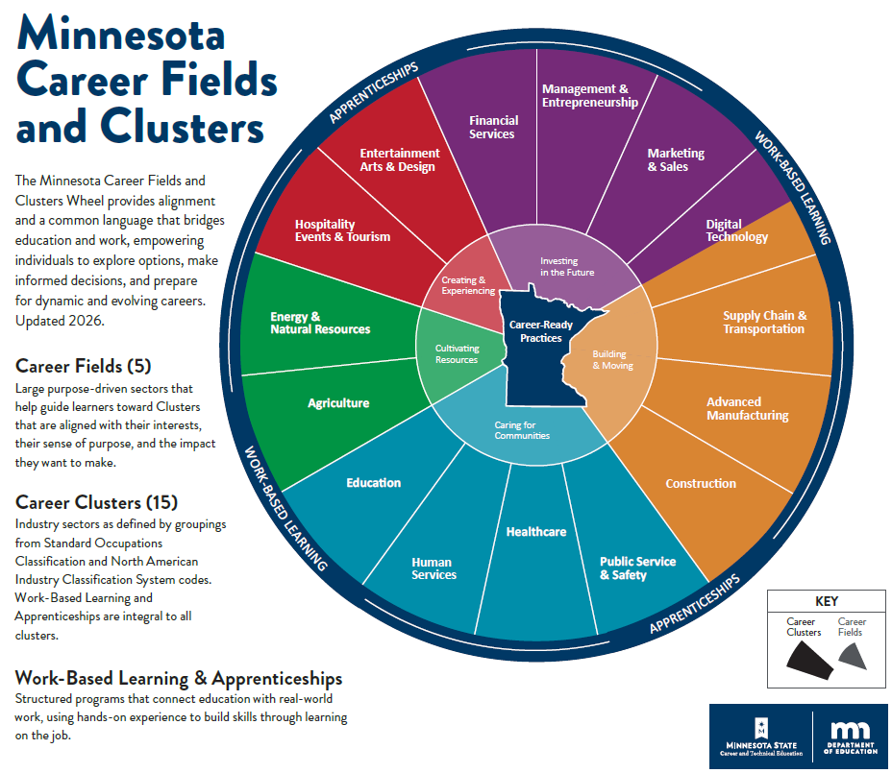

Career Cluster: Career Exploration Program of Study: Foundational Courses
Program Code: 140710 Eligible Licenses: 140050 (primary); 140710, 140100, 140120 (legacy)
Minnesota Frameworks | Minnesota Common Course Catalog (MCCC)
[Course Title] Business and Management Career Exploration | [Course Title] Business/Office Career Exploration
[Course Code] 01 | [Course Code] 12994 (Beginner)

Program Code: 040800 Eligible Licenses: 140050 (primary), 040800 (legacy)
Minnesota Frameworks | Minnesota Common Course Catalog (MCCC)
[Course Title] Marketing Career Exploration | [Course Title] Marketing Career Exploration
[Course Code] 18 | [Course Code] 12151 (Beginner)
Course Description: The emphasis of career pathway study in this course is focused on careers in the Business, Management and Administration field found on the Minnesota Career Wheel. In the Business careers course, students explore career opportunities in three business clusters: Management and Entrepreneurship; Marketing and Sales; and Financial Services. In the Marketing careers course, students explore career opportunities in Marketing and Sales cluster pathways (Marketing and Advertising; Retail and Customer Experience; Market Research, Analytics, and Ethics; and Strategic Sales). Key areas of focus will include: developing self-knowledge of strengths and career interests through personal interest and skills inventories; participating in career fairs, industry tours, and job shadowing opportunities; conducting an informational interview with an employer in each business career cluster; and developing career goals and action plans for achieving them. Students will develop knowledge in the following areas: principles of technology; labor issues; technical and production skills; and personal work habits. Students receive opportunities to practice communication skills through real or simulated job interviews. Participation in student organizations such as DECA and Business Professionals of America (BPA) may be embedded within course activities.
Instructional units in this course may include:
- Preparing for the World of Work
- Knowing Your Strengths and Interests
- Personal Financial Planning
- Exploring Career Clusters in the Business Career Field
- Seeking, Applying, and Obtaining Employment
- Academic Planning for Career Development
Course Progression in this Career Cluster:
Introductory Courses | Intermediate Courses | Advanced Courses
12994 Introduction to Business Careers (140710) OR 12151 Introduction to Marketing Careers (040800) | blank | 12991 Emerging Career Pathway Studies

CTE Course Knowledge and Technical Skill Competencies
Competencies | Sample Measurements
CE12994.01 Describe characteristics of the work environment and personal qualities needed to be employable. | CE12994.01.01 Describe academic knowledge and technical skills necessary to obtain and retain employment.  CE12994.01.02 Describe personal qualities and employability skills necessary to obtain and retain employment.  CE12994.01.03 Explain OSHA standards and common safety concerns in the workplace.  CE12994.01.04 Compare and contrast rights and responsibilities of employers and employees in the Fair Labor Standards Act, Americans with Disabilities Act, and Minnesota Child Labor laws.
CE12994.02 Identify personal skills, interests, strengths, values, motivations and preferences as they relate to career planning. | CE12994.02.01 Identify personal traits, interests, and preferences aligned to potential career pursuits using personal inventory tools.  CE12994.02.02 Identify knowledge and skills aligned to potential career pursuits using skills and aptitude assessments.
CE12994.03 Develop financial plans with employment income to accomplish personal financial goals. | CE12994.03.01 Calculate wages, taxes, and deductions to estimate financial resources available from work in various jobs and career pathways.  CE12994.03.02 Compare and contrast direct deposit, bill pay, and online/mobile banking services of financial institutions.  CE12994.03.03 Develop a personal budget to manage employment income aligned with personal short-term and long-term goals.
CE12994.04 Explore career opportunities in one or more business career pathways to identify opportunities that align with personal career interests and aptitudes. | CE12994.04.01 Identify educational requirements and technical skills needed for business career pathways of interest.  CE12994.04.02 Analyze local and regional business career pathway job growth and labor market information to evaluate potential career pathways.  CE12994.04.03 Analyze and match personal career interests and aptitudes to potential career opportunities of interest in each business career cluster pathway.
CE12994.05 Develop job application documents and interview skills to prepare for obtaining desired employment positions. | CE12994.05.01 Identify multiple print and digital resources for locating information on available career opportunities.  CE12994.05.02 Develop a resume to highlight academic, technical, & personal employability knowledge and skills.  CE12994.05.03 Complete error-free print and electronic job application forms for desired employment.  CE12994.05.04 Develop job interview skills through mock interview and information interview experiences.
CE12994.06 Develop an education and career plan to meet personal and career goals. | CE12994.06.01 Develop a career preparation action plan with both short-term and long-term action steps identified to accomplish career goals.  CE12994.06.02 Create a personal learning plan (PLP) for high school academic course taking based on needed preparation for desired career opportunities.  CE12994.06.03 Compare current personal academic achievement to levels needed for career pathway success.  CE12994.06.04 Explain how participation in activities offered through student and civic organizations can provide valuable career preparation.  CE12994.06.05 Identify postsecondary admission requirements for institutions & programs aligned with career goals.  CE12994.06.06 Compare employment and postsecondary education options available to pursue career interests.  CE12994.06.07 Develop a career portfolio to document knowledge, skills, and experiences.
CTSO Competitive Events Aligned with this Course:
DECA: Principles of Business Administration events (Management and Administration; Marketing; Hospitality and Tourism; and Finance)
Required Safety Training—Potential Topics:
- Current federal, state, and local health and safety laws/regulations specific to the career pathways in this course:
  - Employee rights and responsibilities (roles of labor organizations)
  - Harassment laws: U.S. Equal Employment Opportunity law
  - Human Resource regulations for the workplace
- Ergonomics
- Equipment safety (desktop and mobile devices)
- Online safety (acceptable use policies, protecting passwords, protecting identity information online)
Credentials of Value (Postsecondary Credits, Industry-Recognized Skill or Knowledge Certifications):
NOCTI Micro-Credential: Work Ethics
NOCTI Exams: 21st Century Skills for Workplace Success

Career Cluster: Career Exploration Program of Study: Foundational Courses
Program Code: 140710 Eligible Licenses: 140050 (primary); 140710, 140100, 140120 (legacy)
Minnesota Frameworks | Minnesota Common Course Catalog (MCCC)
[Course Title] Emerging Career Pathway Studies | [Course Title] Emerging Career Pathway Studies
[Course Code] 02 | [Course Code] 12991 (Advanced)

Program Code: 040800 Eligible Licenses: 140050 (primary), 040800 (legacy)
Minnesota Frameworks | Minnesota Common Course Catalog (MCCC)
[Course Title] Emerging Career Pathway Studies | [Course Title] Emerging Career Pathway Studies
[Course Code] 19 | [Course Code] 12991 (Advanced)
Course Description: This course assists students in the development of job-specific knowledge and technical skills related to an emerging career pathway and/or career pathways with non-traditional combinations of technical skills across multiple career pathways. Students will research certifications, industry-recognized credentials, and postsecondary credentials important to starting and advancing opportunities in the selected career pathway. Mentorship with a local business leader working in the career pathway of interest is encouraged. Using the “All Aspects of Industry” framework, students should develop knowledge and technical skills in the following areas related to business cluster careers: business planning; management and organization structure; finance; marketing; and information technology used in business settings. Instruction should prepare students for an industry-recognized credential certification exam.
Instructional units in this course may include:
- Career Pathway Knowledge and Technical Skills Needed in Career Pathway A
- Career Pathway Knowledge and Technical Skills Needed in Career Pathway B
- Connections/Intersections of Career Pathways A and B
- Developing and Expanding Career Pathway Technical Skills Through CTSO Competitive Events
- Expanding Career Pathway Preparation Through Experiential Learning
Course Progression in this Career Cluster:
Introductory Courses | Intermediate Courses | Advanced Courses
12994 Introduction to Business Careers (140710) OR 12151 Introduction to Marketing Careers (040800) | blank | 12991 Emerging Career Pathway Studies

CTE Course Knowledge and Technical Skill Competencies
Competencies | Sample Measurements
CE12991.01 Analyze non-traditional combinations of technical skills across multiple career pathways through student-designed research. | CE12991.01.01 Research and present industry data and employment projections for businesses employing workers in an emerging career pathways of interest.  CE12991.01.02 Analyze causes of the emergence of the career pathway of interest and explain existing and new technical skills that will be required for successful pursuit of career pathway development.  CE12991.01.03 Conduct information interviews with employers working in emerging career pathways of interest to Identify industry-recognized credentials (IRC) valued by business and industry which may improve personal qualifications for employment.  CE12991.01.04 Establish a mentoring relationship with a business and industry partner to assess career pathway growth opportunities and stages of career preparation needed.
CE12991.02 Develop personalized plans for career entry and advancement in non-traditional or emerging career pathways of interest. | CE12991.02.01 Compare and contrast current, non-traditional, and emerging career pathways using the All Aspects of Industry (AAI) framework.  CE12991.02.02 Research and present information on the projected academic and work experience background suggested for successful emerging career pathway entry.  CE12991.02.03 Develop a personalized learning plan (PLP) demonstrating academic and employment steps needed to pursue the emerging career pathway of interest.
CE12991.03 Demonstrate unique connections between emerging career pathways through CTSO competitive event project development. | CE12991.03.01 Analyze available CTSO competitive event project opportunities and develop a proposal for participation in a combination of events to provide preparation for an emerging career pathway.  CE12991.03.02 Develop CTSO competitive event projects that align to preparation for an emerging career pathway.
CE12991.04 Develop technical skills for non-traditional or emerging career pathways of interest through experiential learning opportunities. | CE12991.04.01 Analyze data from industry research and information interviews to identify local/regional industries and businesses as potential employers of workers in a non-traditional or emerging business career pathway of interest.  CE12991.04.02 Develop and apply technical skills for non-traditional or emerging business career pathways of interest through experiential learning opportunities.

CTSO Competitive Events Aligned with this Course:
Contact supervising teacher for list of potential CTSO events aligned to the career pathways study subject matter.
Required Safety Training—Potential Topics:
- Current federal, state, and local health and safety laws/regulations specific to the career pathways in this course:
  - Employee rights and responsibilities (roles of labor organizations)
  - Harassment laws: U.S. Equal Employment Opportunity law
  - Human Resource regulations for the workplace
- Ergonomics
- Equipment safety (desktop and mobile devices)
- Online safety (acceptable use policies, protecting passwords, protecting identity information online)
Credentials of Value (Postsecondary Credits, Industry-Recognized Skill or Knowledge Certifications):
Contact supervising teacher for list of potential credential exams aligned to career pathways study subject matter.

